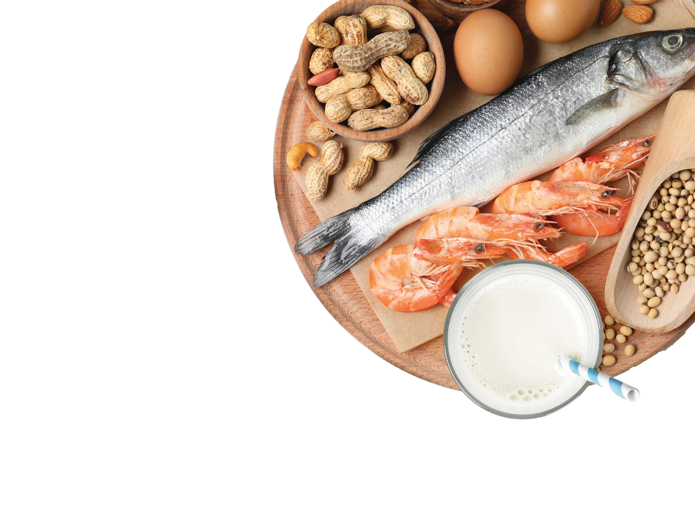

Tuesday,
31 May 2022

Dear COMFA members,

We would like to extend our warmest congratulations to the recent STSM grantees, Dr. Tatjana Jakjovska from North Macedonia, and Dr. Mattia Giovannini from Italy, implementing two exciting projects with the assistance of the Action.

Dr. Jakjovska has recently completed a project entitled “Evaluation of diagnosis and accessibility of optimal core outcome measures for food allergy” under the supervision of Prof. Mirjana Turkalj based in Croatia. Dr. Mattia Giovannini is about to start his placement in King’s College London under the supervision of George du Toit with the aim to review and compare the characteristics and differences between action plans for anaphylaxis.

If you wish to execute a COMFA-related project in any of the eligible countries, please do not hesitate to reply to this email, so that we can discuss this in detail. Application is open to anyone from a COST full member country, and we will appreciate if you forward this announcement to your fellow and junior colleagues as well.

Join the qualitative studies review

To incorporate the output from qualitative data available in the literature, we are planning to complement the list of outcomes generated from the systematic review with a qualitative evidence synthesis (QES). Study is about to begin under the supervision of Prof. Christian Apfelbacher with expertise of Dr. Karen Matvienko-Sikar.

This is an exciting opportunity to learn more about the methodology of such reviews and to contribute to the following consensus process. The review is currently at the planning stage and has to be completed quickly - we expect the first results by mid-October. To get more information and participate, please email Dr Nikita Nekliudov (nikita.nekliudov@oriel.ox.ac.uk).

© 2020 COMFA - COST Action CA18227 / mail@comfa.eu / www.comfa.eu

